.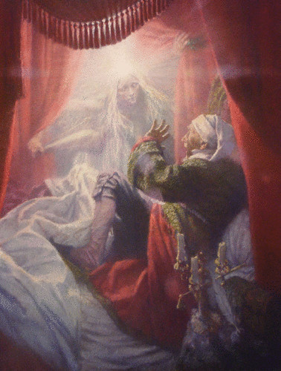
A Christmas Carol Theme Project Choices

- Act out an important scene (individual/pair/group)
  - Choose three crucial scenes from the story that develop your theme
  - Act it out in front of the class or on video
  - Lines must be memorized!
  - Skit should be at least 7 minutes long

- Compose and perform an original song/poem (individual/pair/group)
  - Must address the development of the theme throughout the play
  - Lyrics should accurately reflect details from the story
  - Should be at least 3 minutes long

- Create original art work (individual)
  - Draw or paint three scenes that show the development of your theme
  - Portrayal must accurately reflect description and details from the play

- Comic Book (individual or pair)
  - Depict the development of your theme in comic book form
  - Artwork will be graded! (don’t choose this if you can’t draw!)

- Your idea?
  - If you have a great idea for a different project, ask me about it!

***Groups may not exceed three members***

Requirements for all projects:
- Proposal must be submitted and approved
- Any changes to the proposal must be approved
- Your project must reflect a deep and accurate understanding of the play
- You must present your project to the class
- Your graphic organizer must be submitted with your project

Name: Partner(s):
Class:

Description
Choose a theme from the play adaptation of “A Christmas Carol”. Your assignment is to creatively show how your chosen theme is developed based upon the graphic organizer you completed in class. You have the choice to either work alone, with a partner, or within a group of three. If working in a group, you and your partner(s) will receive the same grade.

Project Checklist
- Completed Graphic Organizer
- Project Proposal
- Project Check
- Final Project

Rubric
Due Date | Product | Points
Mon 12/8 | Proposal | 5
Thurs 12/18 | Progress Check | 10
Mon 1/12 | Presentation  - Good public speaking skills  - Good explanation of your product | 15
 | Final Product  - Accurately represents the play (40)  - Demonstrates creative expression (10)  - Is neat and well organized, visually appealing (10)  - Contains an appropriate amount of material (10) | 70
 | Total | 100

